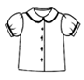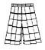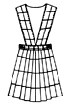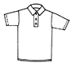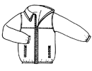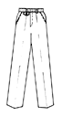
ST. HELEN CATHOLIC SCHOOL
USED UNIFORM DROP OFF
GOING ON NOW!

It’s Time to Drop Off Your Used Uniforms and Support our School!
Bring all of those washed, gently-used school uniforms your child has outgrown and send them in to our school during May! We are in need of all used uniforms that meet school guidelines and that are in good condition. Each used uniform will be sold for $5 each during our Semi-Annual Used Uniform Sale on August 13th. Proceeds from this fundraiser will be used to fund 8th grade graduation activities and scholarships.

**Students who contribute to the Used Uniform fundraising program will be able to come to school in casual dress on the last used uniform drop off day, May 17th! **

USED UNIFORM DROP OFF DATES:
May 1 – May 17
(Drop off used uniforms in the Used Uniform Bin near the school office.)

USED UNIFORM SALE DATE:
Monday, August 13th
(Scheduled to coincide with the first day of school.)

