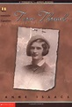
Summer Reading Book Club and Reading Skills with Ms. Silvas
St. Helen Catholic School
June 12-June 29 Tuesdays, Wednesdays and Thursdays (except 6/28th)
9:00-10:00 am
Thinking about summer vacation makes me think about sitting down and enjoying a good book. I want every child to be able to enjoy reading his/her required Summer Reading List and feel prepared to participate in discussions in their 6th grade classroom next year.
Please have your child join me and some of his/her future 6th grade classmates for a Summer Reading Book Club. We will apply and reinforce a number of different reading strategies and skills. Some chapters we will read together and some will be assigned to be read at home. This will allow us to use our book club time for character analysis, identifying story elements and discussion of the story to make sense of the author’s purpose.
(Book Study of Torn Thread by Anne Issacs)
Don’t miss out on your chance to get reading help and be ready for the next school year. $200.00 for 8 one hour sessions in a group of 4 students
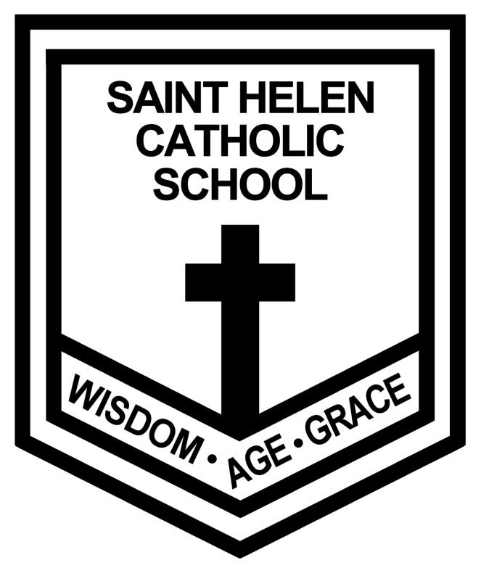 esilvas@sthelencatholicschool.org

